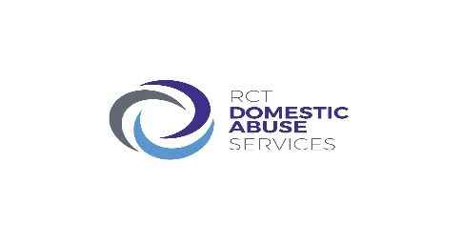

RCT Domestic Abuse Services

Volunteer Application Form

Private & Confidential

Please complete this application form as fully as possible and return to the address on the back page.

Personal Details (All information supplied remains confidential under The Data Protection Act 2018).

Surname:

First name/s:

Address:

Postcode:

Telephone: (mobile) (home)

EMAIL:

Date of Birth……. /……/……

Please state how you know about RCT DAS volunteer service:

Emergency Contact Details

Name:

Relationship:

Address:

Postcode:

Phone: (Mobile) (Home)

Volunteering Information

MOTIVATION: Why do you want to become a Volunteer?

ABUSE/VIOLENCE AGAINST WOMEN: What is your understanding of Abuse Against Women? What is your understanding of Abuse Against Men?

Skills: Do you have experience, skills or personal qualities which you think would be useful for Volunteer?

TRANSFERABLE SKILLS: Do you have any previous experience or transferable skills that would be relevant to the work undertaken at RCT Domestic Abuse Services? This may include academic qualifications, paid and voluntary work, knowledge of foreign languages, special skills such as arts/crafts/cooking/music etc.

On what days and for how many hours a week are you available to volunteer. Please indicate what you are doing at present.

Days: Hours:

Outline any previous work experience (paid or unpaid).
Please make sure you account for any gaps.
Work experience | Date started | Date finished | Reason left employment

Outline any Educational courses or training courses you have or are attending.
Course | Date attended

References: Please give the name of two people we can contact for a reference. It may be someone you have known a long time, or someone you have worked for or a lecturer. We will contact them only if you are successful in your application to volunteer.

Reference 1:

Name
Position Company
Address

Postcode
Email address
Relationship to you (e.g. friend/employer)
Reference 2:
Name
Position Company
Address

Postcode
Email address
Relationship to you (e.g. friend/employer)
DBS CHECKS
Do you have any previous criminal convictions or cases pending? (Please note any information given will be treated with the strictest confidence.).
Yes No
Please note that all members of RCT Domestic Abuse Services staff, both paid and unpaid are subject to police check. However, disclosure will not necessarily mean that you will not be accepted to volunteer with us.

DECLARATION: I certify that the information contained within this form is true and accurate to the best of my knowledge. I understand that should this prove not to be the case, then it may put any offer of volunteering with RCT Domestic Abuse Services at risk.

SIGNED: DATE:

Thank you for taking time to complete this form. Please return along with the Equal Opportunities Monitoring form to:

Michelle Naughton
Volunteer Coordinator
RCT Domestic Abuse Services
Compton House
First Floor Offices
4-5 Victoria Square
Aberdare
CF44 7NT

Tel: 01443 400791
Email: michellenaughton@wa-rct.org.uk

